Sponsorship and Donation Request for DW Poppy Secondary’s 2024 Annual Car Show Fundraiser

Greetings,

The DW Poppy Secondary Car Show is one of the largest and longest running vintage car shows in the Lower Mainland. With as many as 700+ vintage and collector vehicles, the show attracts visitors and participants from all over BC and the USA.

This year’s show is Sunday, May 5, 2024, from 9:00am – 3:00pm on the DW Poppy school field.

We wish to request your consideration on becoming a sponsor or donating items, and to be part of the 35th Annual DW Poppy Secondary Car Show. In the past we have raised over $40,000 in one year for the school!

DW Poppy Car Show Photos
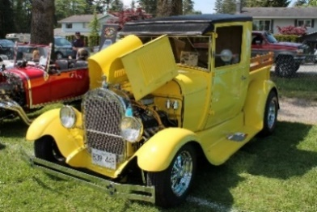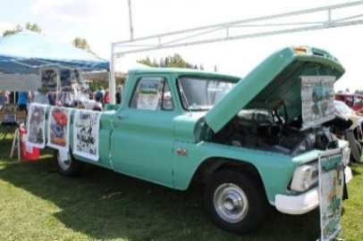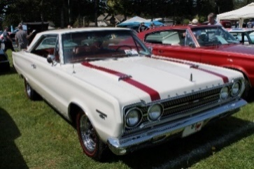
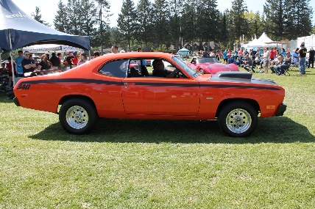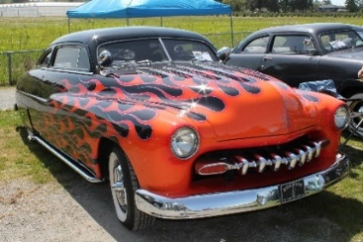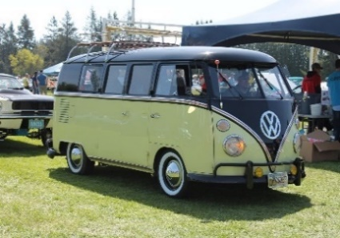
Photos courtesy of Cam Hutchins at carnut.ca

Along with some truly great collector vehicles there is a pancake breakfast, concession, raffle table, 50-50 draws, and various vendors. The best part is, 100% of the proceeds from the show directly benefit the students and school programs including the automotive and technology education classes, Athletics (concession and parking), Dry Grad, as well as other student groups in the school.

Proceeds from this year’s event will go towards a tire mounting machine, lathes, a countertop in the metalwork tool room, tools for trades class, air fryers and replacement of old equipment in the Foods room and other educational program wish list items.

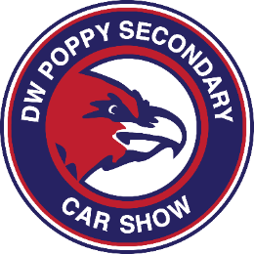

Sponsorship and Marketing Opportunities
- Event and pre-event naming opportunities – poster and t-shirts/merchandise/trophies/dash plaques
- Inclusion in press releases and event programs
- Signage at the event
- Recognition by event speakers from the podium
- Press availabilities
- Recognition on the DW Poppy Car Show Facebook page and Poppy Car Show webpage

Event Benefits
- Tickets to the event
- Cash donations $500 or more will have sponsorship representation displayed at the event in key areas
(The creation and placement of this signage will be at the discretion of event coordinators)

Sponsorship Levels:

Supercharged -- Presenting Show Sponsor $2,750 **SOLD** Thank you Fox and Hound Pub and Restaurant
  - Sponsor show T-shirts with your logo on the back that will be sold at the show, as well as name displayed as presenting sponsor on the posters and online and radio events listings and advertising.
Turbo Charged – Volunteer T-shirt sponsor $1,950
- Sponsor our volunteer’s t-shirts with the car show logo on the front, “Volunteer” on the back and your name on the sleeve that will be worn by our 100+ volunteers
Big Block sponsor: $1,100
  - Dash Plaques Sponsor – your logo along with car show logo on 700+ dash plaques given to participants
  - Swag Bag Sponsor – your logo along with car show logo on 700+ gift bags given to participants
Small Block sponsors: $850
- Trophy Sponsor - your logo on our trophies to the
- Judge Sponsor - your logo on 700+ vehicle registration forms
- Or cash donation $850
Throttle sponsors: $500 minimum donation
  - Minimum $500 cash donation or
  - Donation of equivalent value for Raffle item
Fuel sponsors: $250 minimum donation
- Minimum $250 cash donation or
- Donation of equivalent value for Raffle item
Classic sponsors: $100 minimum donation
- Minimum $100 cash donation or
- Donation of equivalent value for Raffle item

If you would like to become a sponsor or make a donation, or have any questions, please contact myself via email or phone Kerri Winter, Event Coordinator, at poppycarshow@gmail.com or 604-230-9040. Interested vendors also please contact Kerri Winter.

We appreciate your support in helping spread the word about our show to all your customers.

Sincerely,

Jonathan Harris
Jonathan Harris, Principal
604.530.2151 jharris@sd35.bc.ca

